iSTEAMS Multidisciplinary Innovations &
Technology Transfer (MINTT) Conference

&

The Africa Mobile App Development Conference
& Exhibition

Organized by

The Research Nexus Africa Networks

In Collaboration with

The ILORIN BUSINESS SCHOOL
University of Ilorin
Ilorin, Kwara State, Nigeria

An International Science, Technology, Education, Arts, Management & Social Sciences
Conference Series

Theme:
Promoting Research Visibility Through Inter-tertiary Collaborations & Intellectual Competition

27th– 29th September, 2016
www.unilorin.edu.ng
www.isteams.net
info@isteams.net

WELCOME TO THE 2018 iSTEAMS MINTT CONFERENCE

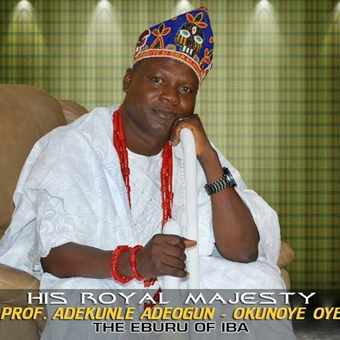
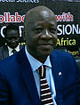

Prof. AbdulGaniyu Ambali (OON)
The Vice Chancellor
University of Ilorin
Ilorin, Kwara State, Nigeria

At the University of Ilorin, our experiences over the last few years strongly indicate the great potential we have as a University in instituting a learning context that is rich in educational opportunities, research and scholarship. The integration of the fundamental requirements stipulated by academic and professional quality assurance bodies, a global-outlook and impact driven learning emphasis, provides a powerful synergy for empowerment in enabling the inculcation of intellectual and creative abilities via a platform of a solid commitment to self-discovery. We are delighted to have Research Nexus Africa Networks and her international collaborative partners support UNILORIN in the furtherance of her mission and vision of promoting research and development activities in the University through collaborative and multidisciplinary strategies that engage modernized and ubiquitous ICTs as one of the key components of today’s institutional drive.

I therefore welcome all delegates to the iSTEAMS MINTT Conference and the Africa Mobile Apps Development Conference holding at the University of Ilorin this year. Enjoy your stay in our University and do make the best of the opportunities offered by this gathering of programmatic researchers, practitioners and academic. It will indeed be Better by far….

His Royal Highness, Prof. Adekunle Adeogun Okunoye - The Eburu of Iba

I am again very delighted to welcome you to the 2016 International Science, Technology, Education, Arts, Management & Social Sciences (iSTEAMS) Multidisciplinary Innovations & Technology Transfer (MINTT) Conference holding between 27th-29th September, 2016. The iSTEAMS conference is a multidisciplinary and collaborative research and practice forum that seeks to explore how new, innovative and emerging forms of technologies can aid research, practices and development in different spheres of human endeavours.

As a royal father with very strong global research and academic antecedents and a pioneer stakeholder for the iSTEAMS Series of Conferences, I remain supportive of proactive and deliberate efforts and any initiative that cluster brilliant minds in a multidisciplinary setting for the purpose of creating synergies that can address the myriads of challenges of growth and development being faced by the world and Africa in particular.

It is on these premises that I again welcome participants to the UNILORIN iSTEAMS MINTT Conference. I desire that participants will create dialogues and streams of ideas, discussions and initiatives that will indeed in a holistic manner promote research visibility through inter-tertiary collaborations & intellectual competition

Wishing all participants fruitful and useful deliberations

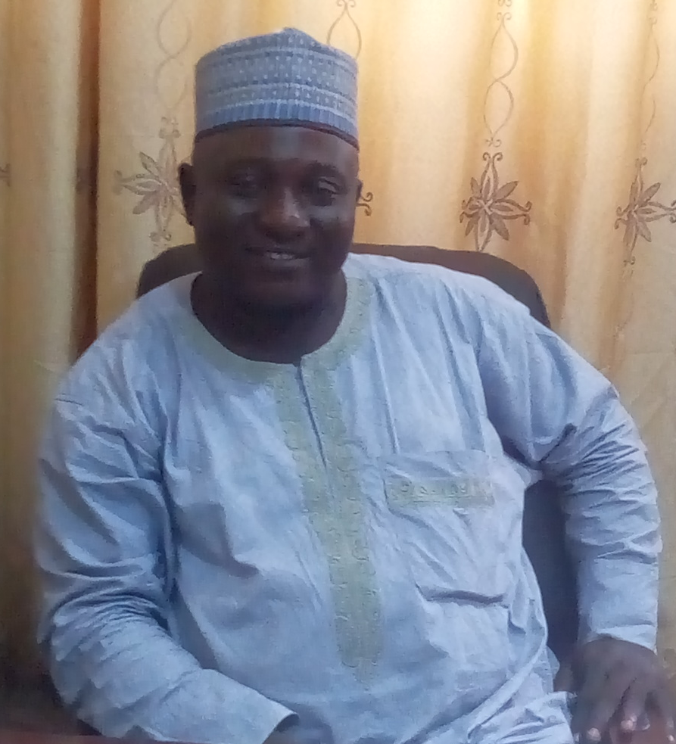
Prof. L.T. Ajibade
Director, Ilorin Business School, University of Ilorin, Ilorin, Kwara State, Nigeria

On behalf of the Ilorin Business School and the Local Organizing Committee I welcome participants to the iSTEAMS/MINTT Conference UNLORIN 2016. This conference tagged “Promoting Technology Transfer & Innovation through Inter-tertiary Collaborations and Intellectual Competition” seeks to address the issues of technology transfer, intellectual protection, intellectual competition, human capital development, innovation, policies, scientific discoveries, education, artistic designs, curriculum, inter-tertiary collaborations and global development by engaging multidisciplinary and collaborative discourses with the hope of seeking and exploring how new, innovative and emerging forms of technologies can be safely and effectively transferred to aid development in different spheres of human endeavours.
While wishing everyone fruitful deliberation throughout the conference, let us work together to promote technology transfer & innovation through inter-tertiary collaborations and intellectual competition. Welcome to a safe, secure, serene and green environment. Experience iSTEAMS MINTT and Discover UNILORIN – better by far.

Prof. Victor Mbarika
President, ICT University, USA
Exec Dir – ICITD Southern University, Baton Rouge, LA, USA

Welcome to the 2016 iSTEAMS/AADCE MINTT Conference at UNILORIN, Nigeria. I know you will not only enjoy great intellectual exchanges, but will also have the opportunity to be a part of the wonderful African hospitality. I have mentioned this in many of my speeches and writing: Africa must write its own research and ICT story. Gone are the days of complaining that Africa does not have “enough” information technologies. Our continent is now immersed with all kinds of ICTs spanning large city centers and rural areas. We now must move towards multidisciplinary and inter tertiary researches in order to maximize the use of these existing technologies as we compete globally. It will not be long from now when students from the Western world will enroll in degree programs offered by African Universities online and offline. In fact it is already happening in small ways and will continue to spread.

Let os all work together and exchange ideas that will help us move our continent and the world at large forward, This indeed is Better by far….

Happy deliberations at the UNILORIN iSTEAMS MINTT Conference.

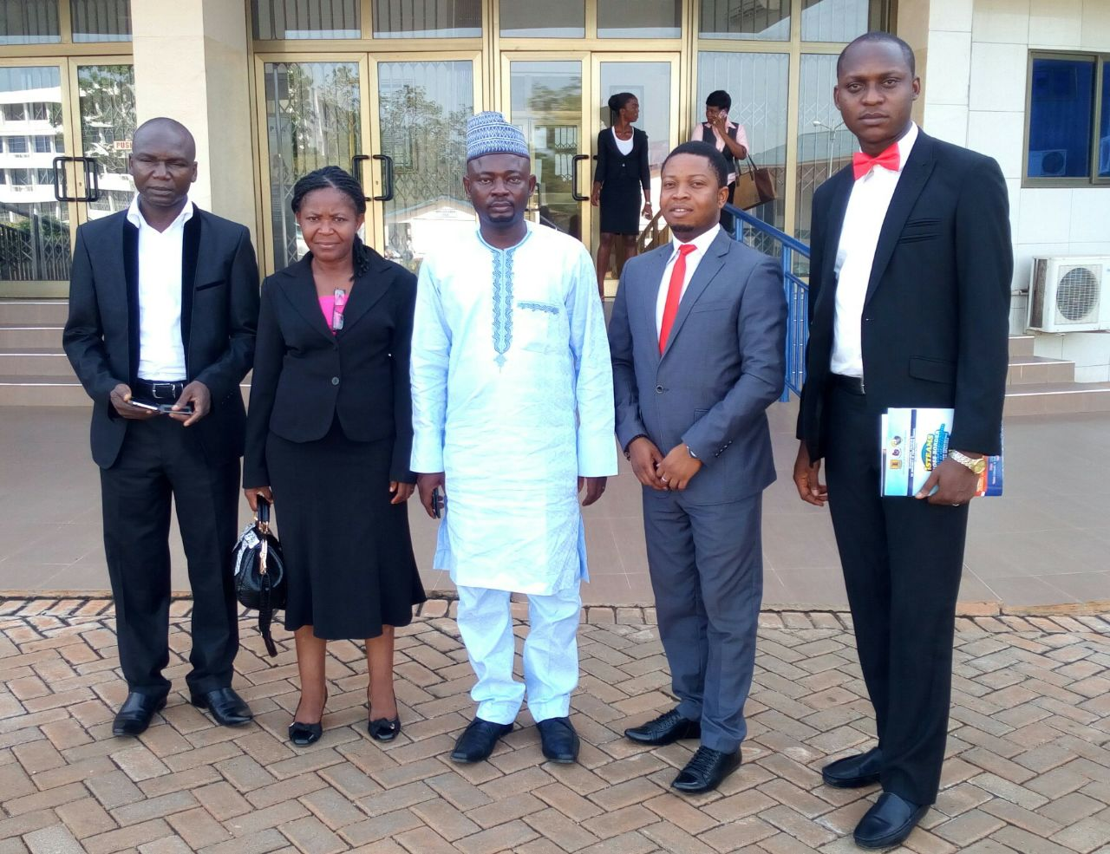

From Left to Right: Prof. Longe O.B, Dr. Deborah Ebem, Dr. R.G. Jimoh, Mr. Orifa Charles & Com. Durosinmi Adekunle
Co-Conveners – iSTEAMS Conference Series.

Participants are warmly welcomed again to another iSTEAMS Series events/conference. Our passion to keep alive the flames of Multidisciplinary research and its attendant benefits remained the primer for the sacrificial and selfless disposition that energizes us to put together events that will propel scholars, practitioners and technocrats alike to address the needs of society through dynamic interactions and proactive strategies borne out of high energy gatherings.

This year's conference tagged "Promoting Technology Transfer, Entrepreneurship & Innovation through Inter-tertiary Collaborations and Intellectual Competition" seeks to go beyond the sparks of activities and forums that provide transient illuminations in the digital skyline. It gravitates towards exploring new and dynamic ways of engaging the potentials offered by inter-tertiary and interdisciplinary collaborations, digitization and ubiquitous ICTs for global growth and development. We believe that your participation will enrich the diversity of perspectives and contents to be presented and that your invaluable experience, insight and contributions will add to what is potentially a very important gathering of pragmatic practitioners and professionals.

Again we welcome you to the University of Ilorin, Ilorin, Kwara State, Nigeria in the State of Harmony - for a blissful and most rewarding Conference.

To our foreign participants, we say welcome to NIGERIA – GOOD PEOPLE, GREAT NATION! Enjoy your time with us.

The 2016 iSTEAMS Multidisciplinary Innovations & Technology Transfer Conference Distinguished Personalities Award of Excellence

The ISTEAMS Award Committee for the 2016 International Multidisciplinary Cross-Border Conference on Science, Technology, Education, Arts, Management & The Social Sciences received several nominations of individuals for the conferment of Award of Excellence on deserving personalities who has in one way or the other supported and encourage pragmatic and proactive initiatives that aligns with our goals of human capital development, inter-tertiary and cross-border collaborations as well as multidisciplinary research.

In 2016, the selection committee zeroed in on laudable contributions from leading University Researchers, Multidisciplinary enthusiasts, Scholars, Administrators, and Practitioners out of which five (5) were eventually selected from the pool of nominees received.

The Research Nexus Africa Networks congratulates our most distinguished awardees and wish them progress in the strides to continue to contribute to educational advancements, research innovations and human capital development.

These personalities and their award are profiled next

Brief on Personalities for the iSTEAMS MINTT
Award of Excellence

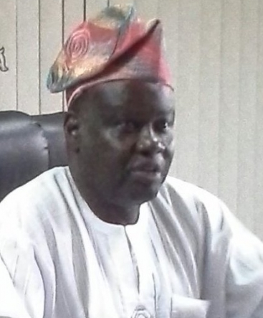

Prof. Lanre Aina
The Director general
National Library of Nigeria

Title of Award
Award of Excellence for Contributions to Research Documentation & Inter-Tertiary Collaborations

Prof. L. O. Aina, was recently appointed and assumed duties as the Director General/National Librarian, National Library of Nigeria, Abuja. He holds B.Sc. Honours Chemistry from the University of Lagos, M.Phil. Information Science from the City University London. He has PGDL and P.hD of the University of Ibadan. He has previously worked at the Universities of Ibadan and Botswana. He also taught in the Department of Library and Information Technology, at the Federal University of Technology, Minna. Professor L. O. Aina is a Fellow of the Nigerian Library Association. He was also President of the Nigerian Library Association .Prof. L. O. Aina is the Pioneer Editor-in-Chief of the most prestigious library and Information Science journal in Africa, the African Journal of Library, Archives & Information Science. The new National Librarian is the immediate past Dean of the Faculty of Communications and Information Science, University of Ilorin and was until his appointment, a visiting Professor, Africa Regional Center for Information Science, University of Ibadan. He is a former member of the 10th Board of The National Library of Nigeria, he is also currently the chairman of the committee on the Revision of the Master in Information Science, University of Ibadan. He was also Dean, Faculty of Communication and Information Science, University of Ilorin and former Head of Department of Library and Information Science in the same University. Professor Aina is well loved by his students and highly respected among scholars nationally and globally.


Dr. Lr.Engr.(Mrs) Deborah Uzoamaka Ebem
University of Nigeria
Nsukka, Nigeria

Title of Award
Award of Excellence for Contributions to International Research Initiatives

Brief On Dr. Lr.Engr.(Mrs) Deborah Uzoamaka Ebem

Dr. Ir.Engr.(Mrs) Deborah Uzoamaka Ebem is a native of Ugbo in Awgu Local Government Area of Enugu State. She was one of the pioneer students of the Department of Computer Science and Engineering at the then Anambra State University of Technology (ASUTECH), Nigeria. She received a B.Engr.(Second class upper division ,21) degree from ASUTECH and a postgraduate diploma in management from University of Nigeria, Nsukka. She also received master’s degrees in computer science and engineering and computer engineering from Enugu State University of Science (ESUT) and the Technical University Delft, The Netherlands, respectively. She is a Dutch certified Engineer (Ir.). She further holds a PhD in computer science from Ebonyi State University, Abakaliki, Nigeria. At present she is a Senior Lecturer in the department of Computer Science, University of Nigeria, Nsukka. From September, 2011 to December, 2011 she was a Research Fellow and Scholar at Massachusetts Institute of Technology, Cambridge USA. Dr. Mrs. Ebem developed a mobile outdoor game for children while at Delft that is being commercialized. She is MIT Open Course Ware (OCW) and Google ambassadors. Dr. (Mrs.) Ebem has published journal articles in both international and local journals. Deborah has published eight text books on Computer Technology for Nigerian secondary schools and for first year course introduction to computer science for colleges and higher institutions in Nigeria. The secondary school textbooks have been approved since 2006/2007 academic session for use in Enugu State. She is an apt teacher, having taught computer science and computer technology to different categories of people: primary, secondary tertiary and corporate organizations two decades.

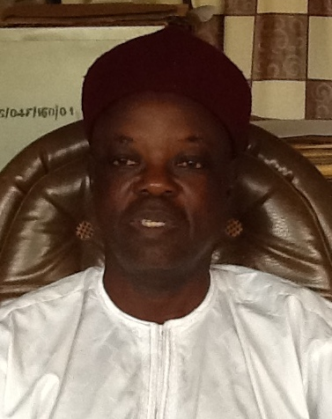

Prof. Sulyman A. AGE
Former Vice Chancellor
Alhikmah University, Ilorin, Kwara State, Nigeria

Title of Award
Award of Excellence for Contributions to Research & Human Capital Development in Africa

Brief On Prof. Sulyman A. AGE

Sulyman Age Abdulkareem was the immediate past Vice Chancellor of AlHikma University, Ilorin, Kwara State, Nigeria. He is a Professor of Chemical Engineering at the University of Ilorin, Kwara State, Nigeria, where he has taught, researched and mentored young scholars and students for over two decades since 1996. He obtained Bachelor's and Master's degree in Chemical Engineering at the University of Detroit, Michigan, USA in 1980. He completed his Ph.D. in Chemical Engineering at the University of Louisville as the Best Graduate Student in 1988. At Louisville, Kentucky, USA he specialized in Heterogeneous Catalysis/Reaction Engineering. Professor Abdulkareem started his professional career as a Graduate Teaching Assistant at the University of Detroit in 1979. He thereafter worked as Advanced Process Engineer with Union Carbide Corporation in West Virginia for two years after which he returned to Nigeria in 1983 for NYSC to serve as an Industrial Engineer with the Nigerian Steel Development Company, Ajaokuta, Nigeria. Professor Abdulkareem was also a Senior Development Engineer at the 3M Company, St. Paul, Minnesota, USA between 1988 and 1992 after which he worked for two years as an expatriate Research Engineer/Assistant Professor at the King Fahd University of Petroleum and Minerals in Dhahran, Saudi Arabia. Since his return to Nigeria in 1994, his research activities have been inspired, driven and guided by his philosophy of creating technology that would engender sustainable development in Africa. To this end, his research focus has largely revolved around Polymer Engineering and Industrial Chemical Process and TechnologySince his return from AlHikma University, he now serves as the Director of Laboratory to Product Centre



Dr. (Mrs.) Pauline Ann Baba
Kogi State University
Ayingba, Kogi State, Nigeria

Title of Award
Award of Excellence for Selfless Contributions to Educational Development in Africa

Brief on Dr(Mrs) Pauline Ann Baba

Dr. (Mrs.) Pauline Ann Baba, earned is a native of Iyal , Dekina local Government Area of Kogi State. She graduated from the Advanced Teachers College (now College of Education) Ankpa, Nigeria (English/RS) in 1986. Holds a Bachelor of Science Tulane Univ., New Orleans, USA - Computer Information Systems in 1994, Masters in Education, Xavier University, Cincinnati – Ohio, USA - Educational Administration(Secondary/Tertiary Education) in 2004 and a doctoral degree, University of Phoenix - School of Advanced Studies. Arizona, USA - Educational Leadership / Educational Technology(EdD/EL/ET) in 2016. She relocated back to her motherland, Nigeria 2011 after living in the United States for over 20 years. Previously she had worked at Tuskegee University, Alabama as a Information Technology Training Coordinator, Xavier University Ohio as the Webmaster and Academic Computing Training Coordinator, Brown Mackie College and University of Phoenix, Cincinnati Campus as adjunct lecturer. She has since returning to Nigeria been using her lifelong learning experiences in the United States of America to better improve the educational and socio-economic growth of her country Nigeria. This has landed her in the Kogi State University’s Educational Foundations department of the Faculty of Education as one of the pioneer staff where she currently teach Psychology of Learning and Special Teaching Methods, Recreation, Guidance and Counseling, ICT in Education, Entrepreneurship and New Business Growth, Computer Applications, and Critical Thinking Skills to mention a few.. She is currently the Director, Kogi State University Information Technology and Resources Centre (ITRC) with a current staff strength of sixteen, Coordinator of the University Library’s automation section, Facilitator with Kogi State University Consultancy Unit’s Human Capacity Development and a A fellow with Institutes of Classic Entrepreneurship (ICENT).

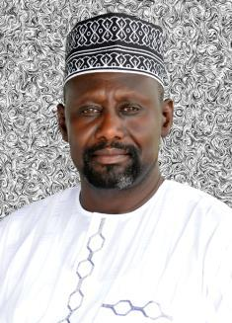

Prof. Musa. Isiyaku Ahmed
Director, COMSITT
University of Ilorin
Ilorin, Kwara State, Nigeria

Title of Award
Award of Excellence for Contributions to ICT Development for Educational Advancements in Africa

Professor Musa Isiyaku Ahmed started his Secondary School at Government Secondary School Waka in 1975 and was later transferred to Government Secondary School Bama where he completed his Secondary Education. His University Education began at the University of Maiduguri in 1981, where he obtained his first degree DVM in 1987 and subsequently went to Ahmadu Bello University, Zaria in 1990 for his Master’s degree and obtained M.Sc. (Parasitology & Entomology) in 1993. In 2003 he was conferred with the membership diploma, College of Veterinary Surgeons Nigeria and by April 2007, he obtained Ph.D degree in Veterinary Medicine at the University of Maiduguri. He later went to the University of Nigeria, Nsukka (2007-2010) and was awarded the Fellowship Diploma of the Postgraduate College of Veterinary Surgeons Nigeria (FCVSN) in September 2010. His areas of research interest are Protozoology and Aquatic medicine where he published 51 articles in peer reviewed journals. Prof. Ahmed joined the services of the University of Maiduguri as an assistant lecturer in 1988 and rose to the rank of Professor (Parasitology) in 2011. He was on Sabbatical appointment at Ahmadu Bello University, Zaria from October, 2012 to September, 2013. He joined the services of University of Ilorin on 2nd October, 2013 as a pioneer staff and Professor in the Department of Veterinary Parasitology and Entomology. He was later appointed as Acting Head of that Department and Deputy Director, Technical and Entrepreneurship Centre in 2013. In August, 2014, Prof. Ahmed was appointed as Director, Computer Services and Information Technology, a position he held to date. He steers the administration of the Directorate with passion, humility, perseverance, dexterity and nimbleness. Prof. Ahmed supervised several undergraduate and postgraduate degree projects which culminated in significant breakthrough and literary contributions to knowledge. He is on the Editorial Boards of several national and international peer reviewed Journals. Prof.. Ahmed was nominated a co-author of “Elsevier Sci Topics”. He enjoyed numerous meritorious awards and Scholarships and served as a member of several national and International professional bodies, Boards and Committees.

Goodwill Message From Mrs. Irene Torshie Attachie, Department Of Midwifery
University Of Health and Allied Sciences, Ghana
At the iSTEAMS MINTT 2016 Conference, Unilorin – Nigeria
On Wednesday 28th September, 2016



The Vice Chancellor, University of Ilorin, Prof. AbdulGaniyu Ambali, all other Principal Officers of the University here present, Deans and Directors, HODs, His Royal Highness, Oba Prof. Adekunle Okunoye, Staff of the University of Ilorin, distinguished participants, our hardworking organizers and convener, distinguished Invited Guests, students and other categories of participants, men of the press, colleagues, ladies and gentlemen

It is a great pleasure and honour for me to be invited as a keynote speaker and also a participant in the iSteams Mintt 2016 Conference, Unilorin; Nigeria. Permit me to seize this opportunity to on behalf of the University of Health and Allied Sciences (UHAS) and particularly my Department; the Department of Midwifery; to express our sincerest appreciation and felicitation to the ISTEAMS team for their efforts and cooperation and all gathered here today.

My university the University of Health and Allied Sciences (UHAS) is a chartered university running exclusively Health programmes at the Tertiary level. The university has six schools under which programmes such as Nursing, Midwifery, Public Health Nursing Medicine, Physician Assistantship, Medical Laboratory, Speech and language Therapy, Dietetics, Physiotherapy, Disease control and the maiden programme Pharmacy, to mention a few. With regard to the objective of our meeting here, UHAS holds a strong believe that such gatherings offer the opportunity for knowledge to be upgraded through intellectual interaction with the multidiscipline experts in the various fields. We believe that participants in such conferences do not only learn or enhance our knowledge in our chosen fields or the global environment but we also build relationships for a closer cooperation which in turn promotes healthy competition that will cyclically promote knowledge and improve on human existence at large.

Knowledge in my area of practice, Midwifery; (an old if not the oldest profession) used to be through apprenticeship but today it is being practiced under the Evidence based Concept which encourages research; therefore Practitioners in this field appreciate such platforms that provide a collection of innovation and pragmatic mechanisms which helps to train professionals to be well equipped provide solutions to the challenges that confront society through research. Such multidisciplinary conferences offers a platform for decision makers and stakeholders to be exposed to information that society needs to access to improve livelihood. Consequently participants are informed, our mind disabused and we get challenged to move on to higher levels. Hence the relevance of theme for this conference: ‘Promoting Research visibility through inter-tertiary collaborations and intellectual competition’.

The 6th conference in Accra was on Addressing Human Challenges and today we are here Promoting Research visibility; as a result I will share with us “the psychological aspect of infant loss” (stillbirth; a phenomenon which affects people from all walks of life) subsequently. I also recognize that this conference will play a key role in promoting future international, intercultural, and inter-organizational cooperation and thus contribute to academic excellence in this era of knowledge-intensive collaborating society; I am confident that this conference will build on the goodwill established during the previous years and cooperate in realizing a unique vision for the establishment of common grounds to make significant contributions to academia both locally and internationally.
To conclude, I will join my sister country (Nigeria) to welcome all of you especially the Non-West Africans. UHAS and Ghana looks forward to hosting the next conference, you are welcome in advance.

Have a fruitful deliberations.

Thank you.

MRS. IRENE TORSHIE ATTACHIE
PROGRAM OF EVENTS

CONFERENCE DAY 1- Tuesday, 27th September, 2016

ARRIVALS/REGISTRATION/LOGISTICS
Main Auditorium, University of Ilorin, Ilorin, Kwara State, Nigeria

CONFERENCE DAY 2- Wednesday. 28th September, 2016

Opening Programme and Conferment Of Awards Of Excellence

Main Auditorium, University of Ilorin, Ilorin, Kwara State, Nigeria

 | Comrade Durosinmi Adekunle & UNILORIN PRO
TIME FRAME(S)
08:00-10:00  10:00-10:30  10:30-10:50  1050- 11:00  11:00 – 11:20  11:10-11:30  11:30:-12:00  12:30 – 1:00  13:00- 14:00 | Conference Registration and Networking  Courtesy Visit By the Organizers & Dignitaries to the VC – UNILORIN  Recognition of Dignitaries  Opening Remarks  The Changing Tides with a Constant Need - Imperatives for Intellectual recapitalization  Prof. Olumide Babatope Longe - Distinguished Fulbright Scholar & Co-convener iSTEAMS MINTT  Remarks from the LOC Chair  Dr. R.G. Jimoh – Associate Professor & Deputy Director – UNILORIN Business School  Remarks from the Host - Prof. L. Ajibade – Professor & Director – UNILORIN Business School  Welcome Address by the Vice Chancellor  Universities in Diversities - Inspiring Inter-tertiary and Multidisciplinary Research through Inter-tertiary Collaborations  Prof. AbdulGaniyu Ambali (OON) - The Vice Chancellor, University of Ilorin, Ilorin, Nigeria  Keynote Address 1  A Microbiologist can read your mind - Seeing the unseen opportunities in a globalized world.  Prof. O.M. Oyawoye – Consultant on Environment & Former Commisioner of Environment, Osun State  The Human Angle – Psychological Impact of Still Birth On Families In Africa  Mrs. Irene Attachie - University of Health & Allied Studies – Ho, Volta Region, Ghana  CONFERMENT OF AWARD OF EXCELLENCE  LAUNCHING OF THE SOCIETY FOR MULTIDISCIPLINARY & ADVANCE RESEARCH TECHNIQUES (SMART)

14:00- 15:00 Lunch

15:00-15:30 | Keynote 3  E-Health/Telemedicine Research Development Issues in Developing Countries Context - Business Opportunities and Prospects  Prof. E. Justice - Ladoke Akintola University of Technology, Ogbomosho, Nigeria
15:30-18:00 | Parallel Paper Presentation Session
CONFERENCE DAY 3- Thursday 29th September, 2016

Main Auditorium, University of Ilorin, Ilorin, Kwara State, Nigeria

Moderators | Com. Durosinmi - Dots Institute of Technology, Abeokuta, Nigeria  Mrs Mughele Ese Sophie – Delta State School of Marine Technology . Adewole K.S
TIME FRAME(S)
10:00-10:30  10:30-11:00 | DEMOS  DEMO 1 : JustAgrik  Mr. Olayinka Adebayo  AGRINNOVATION – Promoting the Use Of Technology in Revolutionizing Agriculture  Keynote Address 4  Challenges in the Integration of ICTs in the Teaching and Learning Environment.  Prof. Musa. Ishyaku Ahmed – Director COMSITT, University of Ilorin, Ilorin, Nigeria

11:00 – 11:30 REFRESHMENT

11:30- 12:30 PARALLEL PAPER PRESENTATION SESSION

2:30 – 3:30 CLOSING EVENT - Appreciations & Presentations of Plaques of Recognitions

4:00 – 6:00 TOUR OF UNILORIN

The Conference Organizing Committee Are Grateful To Everyone Who Contributed To Making The 2016 ISTEAMS MINTT Conference A Success &
Wishes All Our Participants A Safe Journey Back To Their Various Destinations

Announcing The ISTEAMS Research Nexus Conference, 2017

CALEB UNIVERSITY
Imota, Lagos State, Nigeria

Details Date Will Be Announced Later

If your institution is interested in hosting any of the ISTEAMS series of conferences please contact us by e-mail through info@isteams.net or call +2348160900893 or +2348154413298

PAPERS SUBMITTED AND ACCEPTED FOR PRESENTATION

S/NO | AUTHORSHIP | TITLE OF PAPER
1 | Suleiman Bashir Adamu And Lawan Sani Taura | 1D Klein-Gordon Equation In An Infinite Square Well With PT-Symmetry Boundary Condition
2 | Gabriel Iwasokun, Richard Akinyede And Oluyomi Akinyokun | Fingerprint-Based Authorization Platform For Electronic-Based Examination
3 | Toyin Adekanmbi | Physico-Chemical Analysis Of The Oil Extracted From The Edible Part Of Walnut (Tetracarpidium Conophorum)
4 | Babatunde Lawal | A Review Of Data Storage Security Approaches In Cloud Computing
5 | Babatunde Lawal | Introduction Of E-Learning To Secondary Schools In Nigeria
6 | Muhammad Sani Nahannu, Abdullahi Danbaba Abdullahi And Halisa Sani Gadanya | Phytochemical And Antidiarrhoael Studies Of The Leaves Of Clerodedrum Aculeatum (Verbenaceae)
7 | V. N Effiom And D. I. Ogbaji | School Learning Environment And Students’ Academic Performance In Social Studies In Calabar Municipality Of Cross River State, Nigeria
8 | Folashade Ibitowa And Solomom Akinola | A Review On Software Testing
9 | J. B. Awotunde, R.G. Jimoh And A. Ameen | Using Digital Map With Geographical Information System For Ranches Search, Secure And Rescue (SSAR)
10 | O.J. Lateef, U.S. Haruna, M. S. Adebusoye And D. I. Adamu | Maternal Knowledge And Awareness On Vitamin A Supplementation And Its Effect On The Eradication Of Xerophthalmia Among Infants In Bauchi Metropolis
11 | Young C.C. | Scientific Evaluation Of The Performance Of The National Directorate Of Employment (Nde)
12 | Alaba Omoshule And Oyebiyi Oyediran | Attitude Of Mobile Telecommunication Subscribers Towards Sim Card Registration In Oyo State, Nigeria
13 | Oyebiyi Oyediran And Alaba Omoshule | Use And Non-Useof Information And Communication Technology By Small And Medium Enterprises In Ogun State, Nigeria
14 | Kehinde Kanmodi, Oluwatobi Olukoya And Abimbola Akinloye | Perception Of Natal Tooth Among Trainees In Primary Health Care-Related Programmes In Ibadan, Nigeria
15 | J Ayisi, Gm Kivengea And Ga Ombakho | Initiatives To Promote Commercialization Of Research Outputs By Kenyan Universities
16 | I.A. Alhaji, B. I. Tijjani And M. H. Ali | Determination Of Perfromance Enhancement In Ieee 802.11 Multi-Rate Wlan
17 | Mukhtar Baba And Hoe Chee Hee | The Relationship Between Entrepreneurial Orientation, Entrepreneurial Education, Self-Efficacy And Entrepreneurial Intention Among Undergraduate Students At Nigerian Universities
18 | Abdurrahman Adamu Pantamee | Further Evidence On The Effect Of Board Size And Board Composition On Firm Performance
19 | Simon Philip | Automatic Title Extraction From A Research Paper In A Digital Library
21 | Bashir Olaniyi Sadiq, Sikiru Olayinka Zakariyya, Ibrahim Emmanuel, Adamu Abubakar Saidu And Okechukwu Ochia | Development Of A Student Self Study Andriod Mobile Application For Higher Institutions
22 | Oluwatobiloba Olanrewaju And Kehinde Kanmodi | The Proof For Beal Conjecture: A Mathematical Analysis
23 | Sawiat Oziohu Isa, Abass Bolaji Isiaka And Hafsat Imam Alabi | Availability And Level Of Use Of Laboratory Facilities In Teaching And Learning Of Biology In Senior Secondary Schools: Implications For Sustainable Development
S/NO | AUTHORSHIP | Title Of Paper
24 | Olomu Michael Oluwaseun, Irefin Isaac Adeyemi, Olomu Eniola Olubunmi, Ajao Blessing Funke And Atoyebi Musiliyu Kunle | Success Factors Of E-Marketing Innovation Adoption: An Empirical Investigation Of The Nigerian Manufacturing Firms
25 | F. S. Ishaq, I. A. Alhaji, Halis Altun, Jawad Muhammad And S. A. Sani | Analysis On Object Detection Using Artificial Intelligence For Industrial Applications
26 | Suhurat Ikeola Olatinwo, Joseph Bamidele Awotunde, Adedoyin Simeon Adeyemi And Alfa Abdullahi Abdullahi | A Framework For Development Of An Intelligent Tutoring And Assessment System With Adaptive Behaviour
27 | Adenle B.J, Adekusibe K.G, Alashiri O.A And Akinrogunde O.O | Mitigating The Menace Of Electrical Fire Outbreaks In Building: An Unparalleled Protection
28 | S.A. Amoo And I.J. Eluga | Nonlinear Magnetohydrodynamics (MHD) Boundary Layer Flow Embedded In Porous Media Over A Stretching Surface
29 | Muhammad Isah Suleiman | Percied Influence Of Healthful School Environment On Students’ Health In Secondary Schools In Kano State.
30 | V. N. Effiom And Gimba Joseph | Social Studies Education , A Tool In Reducing Examination Malpractice .
31 | Bunakiye Japheth And Edward Ogheneovo | Perspectives Of Object Orientation In A Database Management System
32 | Simeon Odetunde, Wahab Saheed And Sheu Shofolufe | Effect Of Fungi And Fungi Secondary Metabollite (Mycotoxin) On Blood Parameters And Liver Function Of An Albino Rat
33 | Victor Iboyi | Conceptual Framework For E-Voting Using The Automated Teller Machines: A Proposal For Stable Democracy In Nigeria
34 | Tiamiyu Yinusa Bolanle And Omiola Mathew Adetayo | Effect Of Video-Based Mobile Learning On Distance Learners’ Academic Performance In Logarithms Concepts In Mathematics.
35 | Lawal Olanrewaju, Logunleko Abolore, Olaitan Omotayo And Logunleko B Kolawole | State Of Affairs In Ict Usage In The Hospitality Industry: A Case Of Hotels In Abeokuta, Ogun State, Nigeria.
36 | Ojo Emmanuel Ademola | Towards A Strategy For Management Innovation
37 | O.J. Lateef | Physical Activity Practice And Nutritional Status Of Students In Public Secondary School In Kwara State, Nigeria
38 | Zulfah Jumoke Abdulkareem, Wahid Damilola Olanipekun And Aminu Nassir Brimah | Impact Of Electronic Marketing Adoption On Organization Performance - Evidence From Nigerian Banking Industry
39 | Victor Iboyi | The Science Of Managing A Technical Team In Software Project
40 | Ojo Ademola | A Not Knowing: Gaining An Understanding Of The Future Of Management
41 | Muhammad Lawan Jibril | Using Decision Tree Data Mining Algorithm To Predict Causes Of Road Accident And Accident Prone Locations Along Kano -Darazau-Gombe High Way
42 | Okonkwo Victor Okechukwu. | Ebola Haemorrhgic Fever: Its Impact, Challenges And Control Strategies In Nigeria.
43 | Abayomi Agbeyangi, Joseph Odiete, Olujide Adenekan And Adam Olorunlomerue | Review On Uavs Used For Aerial Surveillance
44 | Ahmed Danasabe Suleiman, Osinachi Ubadike And Musa Aibinu | An Adaptive Least Mean Squared Data Compression Algorithm For Healthcare Monitoring In Wireless Sensor Networks
S/NO | AUTHORSHIP | TITLE OF PAPER
45 | Adekunle Adeoye Eludire, Olusegun Olayinka Lawal And Victor Akinbola Olutayo | Service Quality Of The Global System For Mobile Telecommunication Industry: Subscribers’ View
46 | Risikat Abimbola Akinseye | Increasing Government Legitimacy In A Hostile Environment
47 | Awodele-Fayomi Ikeoluwapo Omolara | The 21st Century Nigerian Youths: National Asset Or Liability?
48 | Onifade Martha Seyi | Adequacy Of Chemistry Laboratory And Its Activities Effect On Learning Chemistry: The Students And Teachers’ Perception.
49 | Hope Amba Neji And Ann Meremikwu | Investigating The Effectiveness Of Collaborative/Team Teaching Strategy On Students’ Academic Performance In Science And Mathematics In University Of Calabar, Nigeria.
50 | Genevieve N. Aglazor | Curriculum Expansion For Life Long Learning In Primary Schools In The Calabar Municipality Of Cross River State – Nigeria
51 | Dele Oyeniyi Ajala | Ict: A Stranger In The Urban Planning Practice, Findings And Reflections On Osogbo.
52 | Olugbenga Solomon Adebukunola, Oluwaseun Ayodeji Odusanya And Adebayo Oyefusi | The Relevance Of Statistical Analysis In Enterpreneureship Management Decisions In Nigeria. An Assessment Of Selected Medium Scale Enterprises In Lagos Metropolis.
53 | P.M. Enyong | Performance Appraisal Of A Direct-Current Motor Through An Experimental Determination Of Its Rotational Inductances And Open-Circuit Curves
54 | P.M. Enyong | Developing A Short Transmission Line Module For Electrical Power Laboratory Application
55 | Seyi Abatan | Impact Of Environmental Quality On Performance And Productivity Of Tertiary Institution Staff: A Case Study Of Moshood Abiola Polytechnic, Abeokuta.
56 | Stephen Oluigbo And Uthman Moyo | Pre-Building-Phase Design Considerations And Maintenance Challenges Of Performing Arts Theatre Buildings In Nigeria
57 | Stephen Oluigbo And Uthman Moyo | Innovations In Sustainable Housing: Case Study Of Plastic Bottle Housing, Sabon-Yelwa
58 | Jumoke Soyemi | Development And Implementation Of Biometric Fingerprint Attendance Management System In Tertiary Institutions
59 | David Kolo And Samuel Jiya | Development Of A Cloud-Based Mobile Learning System: An Application Of Ict In Education
60 | Daisy Nkweteyim, Damen Ngatchu And Harry Ngatchu | Mas Based Simulation Of Tardiness In Universities: The Case Of The University Of Buea
61 | Olayinka Yusuf And Jimoh Rasheed | Understanding Evolving Developments In Electronic Voting System From A Security Perspective
62 | Olukemi Omolola Ogunniran | Influence Of Information Communication Technology On Quality Of Teaching In Selected Tertiary Institutions In Osun And Ogun States, Nigeria
63 | Mujidat Olusola Ogunyemi | Strategic Planning In Human Resource Management In Higher Institutions (Obafemi Awolowo University As A Case Study)
64 | O. A. Lawal | Wireless Sensor Networks: Its Application, Challenges And Solution.
65 | Binta A. Muhammad | Effects Of Teaching With Metacognition On The Academic Performance Among N.C.E Integrated Science Students In Kaduna State – Nigeria.
S/NO | AUTHORSHIP | TITLE OF PAPER
66 | Chinaenye Emelike, Johnpeter Uzoma And Emmanuel Nwangwu | Investigation Into The Consequence Of Emotional Intelligence Management On Computer Science Undergraduates Academic Performance
67 | Ismaila Temitayo Sanusi | Effect Of Social Network Usage, Peer Influence And Gender On Students’ Academic Performance In Igbomina Land Of Osun State.
68 | Binta A. Muhammad | Effects Of Teaching With Metacognition On The Academic Performance Among N.C.E Integrated Science Students In Kaduna State – Nigeria.
69 | Binta A. Muhammad | Effects Of Teaching With Metacognition On The Academic Performance Among N.C.E Integrated Science Students In Kaduna State – Nigeria.
70 | James Abah, P. Mashebe And S. A. Onjefu | Assessment Of Heavy Metals Pollution Status Of The Pasture Grass Around Katima Mulilo Municipal Solid Wastes Dumpsite, Namibia
71 | Irene Attachie | Mothers’ Psychological Experiences Of Stillbirth: A Study In The Accra Metropolis
72 | Ayodele Ojo | Finite Difference Methods For The Numerical Approximations Of One-Dimensional Advection-Diffusion-Reaction Equation By Simple Implicit And Crank Nicolson Schemes
73 | Oluwatoyin O Akinrogunde | Sustainable Rural Development Strategies As A Means Of Stemming The Effects Of Rural-Urban Migration In Nigeria.
74 | O. Moses Olaniyan, Mutiu Adegboye, Bolaji Omodunbi And Adebimpe Esan | Electronic Health Technology And Its Application Area: A Review
75 | Olufemi Odekunmi, Famous Chukuma, Olalekan E. Oginni, Akinola Olusola O. And Akinrogunde Oluwatoyin O. | Urbanization As A Causative Factor For Slum Formation And Informal Settlements In Lagos, Nigeria: Problems And Solution
76 | Nurudeen I. Mohammed, Nassereldeen A. Kabbashi, Abass O. Alade And Md. Zahangir Alam | Performance Of Renewable Heterogeneous Catalysts In Biodiesel Production
77 | Adekunle Durosinmi, Olatunbosun Kaka, Olaitan Alasiri And Oluwafemi Akinwunmi | Analyzing And Defending Against Malware
78 | Dauda La'Ah, Deborah Ayuba Damina And Useni Sambo | Establishing The Training Needs Of People With Physical Disabilities In Rice Production: Implications For Agricultural Extension Services
79 | Ajayi Olusola. O., Akinrujomu Oluwatobiloba. S. And Anifowose Adekunle. O. | Comparative Analysis Of Students’ Performance In Computer Programming Paradigms
81 | Ajayi Olusola Olajide And Falana Taye Fredrick | Empirical Evaluation Of Data Hashing Algorithms For Password Checks In Php Webapps Using Salt And Pepper
82 | Vincent A. Balogun And Isuamfon F. Edem | Swept Angle Optimisation And Its Influence On The Specific Cutting Energy In Milling Aisi 1045 Steel Alloy
83 | Olutoyin O. Bamigboye | Effect Of Fungal Degraded Maize Cob Supplementation Of Broiler Diet On The Haematological Parameters And Economic Performance Of Fed Chicks
84 | Deborah Ebem And Joseph Onyeagba | Internet Banking: Identity Theft And Solutions - The Nigerian Perspective
S/NO | AUTHORSHIP | TITLE OF PAPER
85 | Oluwafisayo Babatope Ayoade, Francis Kayode Taiwo, Ebenezer A Oluwatusin And Gabriel Babatunde Iwasokun | An Intelligent System Framework For Computer Maintenance Record System (A Case Study Of College Of Education, Ikere Ekiti)
86 | G.O. Korter | Technology Innovation For Educational Advancement : An Empirical Evidence
87 | G.O. Korter | Spatial Analysis Of Cancer And Alcohol Consumption In Africa
88 | John Maphephe | How The Use Of Social Media Networks Can Influence The Growth Of The Lesotho Political Economy Beyond The 50 Years Jubilee Celebration Of Independence.
89 | Olusola Olajide Ajayi And Tolulope Olawale Elemese | Analyzing The Influence Of Various Fuzzification Methods In The Evaluation Of Netbeans Java Components’ Interface Complexity For Reusability
90 | Olushola Olajide Ajayi And Tolulope Busayo Aderele | Analyzing The Effects Of The Different Defuzzification Methods In The Evaluation Of Java Components’ Customizability For Reusability
91 | David Edu | Students’ Perception Of Concepts And Their Academic Achievement In Basic Science In Cross River State, Nigeria
92 | Yakubu Jibril | Encouraging Scientific Entrepreneurship Through Biotechnology Education In Nigerian Polytechnics For Sustainable Economic Diversification.
93 | Olusola Olajide Ajayi And Temitope Clement Akindele | A Neuro-Fuzzy Model For Predicting Students Performance In Object-Oriented Programming Courses

